PREVIOUS SPONSORS


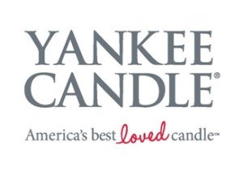
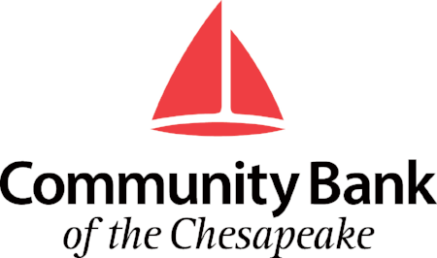



23rd ANNUAL ST. COLUMBA CHARITY GOLF TOURNAMENT
MONDAY, JUNE 8, 2020

WICOMICO SHORES GOLF CLUB
35794 Aviation Yacht Club Road, Mechanicsville, MD 20659



Registration: 8:00 AM
Tee Time: 9:00 AM
Captain’s Choice

A portion of the proceeds benefit
Spring Dell Center, JDI DELMAR & RiteCare

Directions: Rt. 301 South to Rt. 234, Left on Rt. 234 to Wicomico Shores Road, Right on Wicomico Shore Road. Clubhouse telephone number is 301-934-8191.

ENTRY FORM
Pre-registration Fee (May 21st): $100 per golfer/$400 per Foursome
(MAX OF 124 GOLFERS)

NOTE: Individual players will be placed in a foursome.

NAME | PHONE NUMBER

ABOUT THE ST. COLUMBA OPEN

Our 23rd Annual Open Golf Tournament is upon us. This year’s charity recipients will be the “Spring Dell Center”, JDI DELMAR and RiteCare. These organizations do great work in our community. We hope once again to see you at the Wicomico Shores Golf Club for a great time by all.

DAYS EVENTS

(8am) Breakfast

(11am) Lunch

Closest to the pin (1 hole) and longest drive (1 hole) Men and Women contest

First, second and third place finishers’ prizes

Two Holes will be sponsored by Dixon Golf at a fee of $10 and $20 (Longest Drive and Closest to the pin)

There will be a “50/50” Drawing

There will be three (3) Par 3 Challenge holes for huge prizes!

Tons of Door Prizes provided by local businesses

Drinkers Delight Raffle

Mulligans and String will be available

AS USUAL, THERE WILL BE DRINKS AVAILABLE THROUGHOUT THE DAY, WITH BEVERAGE CARTS ROAMING THE COURSE.

MAKE ALL CHECKS PAYABLE TO:
ST. COLUMBA LODGE NO. 150

Credit Card/Debit Payment Option is available

For more information to register online or pay online please go to:

WWW.STCOLUMBA150.ORG/GOLF

Please contact our Public Relations lead for sponsorship options

Jeremy Anderson or Craig Meinhardt
Phone: 757-395-7028 or 301-653-7238
E-mail: golf@stcolumba150.org

